- Solving problems using array functions on rest countries data.
  - Get all the countries from Asia continent /region using Filter function
Code:
var sum = obj.filter((x)=>{
if(x.region ==="Asia")
console.log(x.name)}
);
Output:
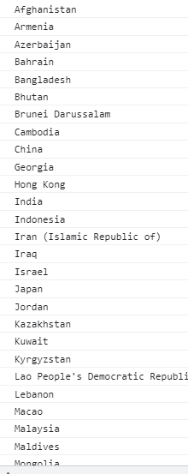

  - Get all the countries with a population of less than 2 lakhs using Filter function

Code:
var sum = obj.filter((x)=>{
if(x.population < 200000)
console.log(x.name)}
);

Output
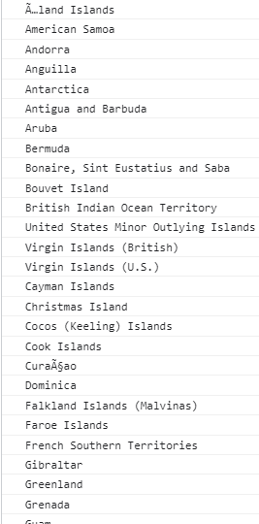

  - Print the following details name, capital, flag using forEach function
Code
obj.forEach((x)=>{
for(var key in x){
console.log(x.name, x.capital, x.flag);
}
});

Output
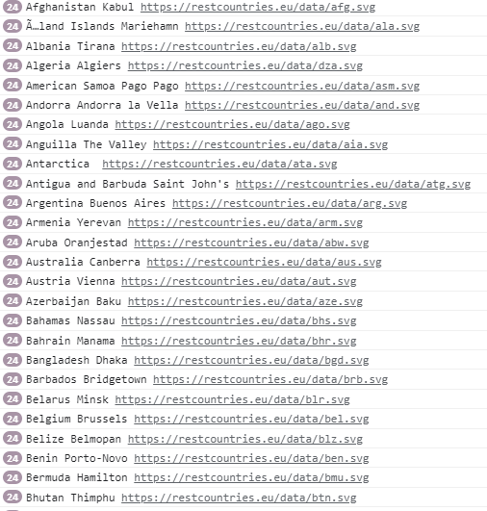

  - Print the total population of countries using reduce function

code
var s=obj.map((x)=>{
return x.population;
})
.reduce((first,second)=>first+second);
console.log(s);

Output:
7349137231

  - Print the country which uses US Dollars as currency.

code
var s=obj.filter((x)=>{
if(x.currencies.code==="USD")
return x.name;
})
console.log(s);

Output:
[] – No data found. If found please tell me correct coding in comment

